3.

Web Server Scanning with Nikto

5.

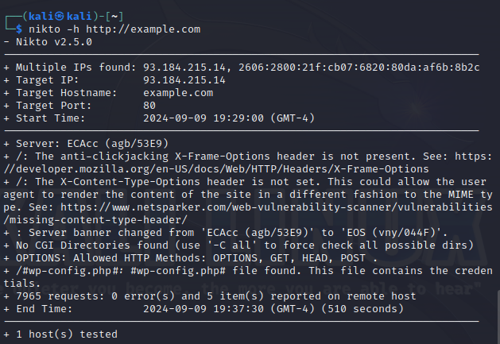

Part 3: Vulnerability Scanning with OpenVAS

